Character Controller

This is scrip controls the movement of object using the joystick of a controller. Using the action button allows to object to jump. Also, can be attached audio source that would play the sound as the player hold the joystick direction. The script is attached directly to the object that will use it and manipulate the Rigid Body.

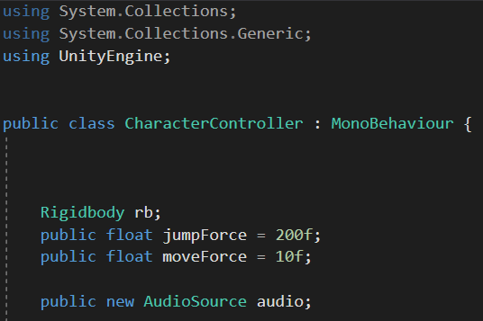

On the image above we see references to Rigid Body and Public Floats for the Movement and the Jump with values that can be changed later into the inspector. Also, in the inspector will appear a link to an Audio Source, that can be dragged directly into that. In the Void Start we just refer to the Rigid Body attached to the object that would be moved.

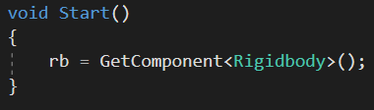

The class is being updated by the input of buttons. In the first part I put the jump button as its not so complicated. The script gets information from the input of Space Button or Joystick Button Number 1 and apply force towards the Y Axis of this object. Its important to set the other values to zero as we do not want the object jump to go diagonal or any other type of distorted movement. For all the movements has been applied an Impulse Force (mass\*distance/time), which is an instant Force dependent on the object’s mass.

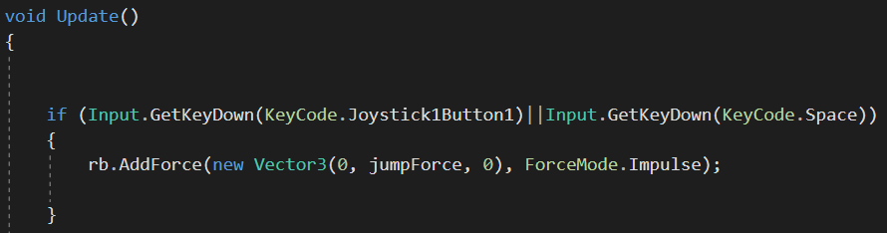

For the movement of the object is a bit more complicated as we need to keep on mind the correct directions to apply force. Just a quick note that even if the directions are being mistaken, into the Project Settings for Input we can invert the directions to match the Joystick. First, I prepare the Left and Right movement which is taking information from the Horizontal Input of the Joystick. The script is basically looking for Positive or Negative values on the X Axis and apply Impulse Force according to that vector.

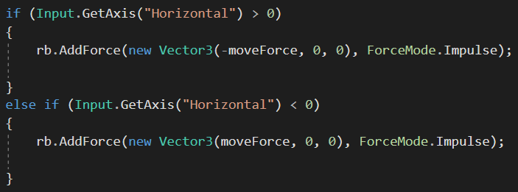

Forward and Backward movements are done the same way, by receiving values from the Joystick’s Vertical Movement. If the values are more than zero it will apply Positive Impulse on the Z Axis, and if the values are less than zero it will apply Negative Impulse to the Z Axis of the object.

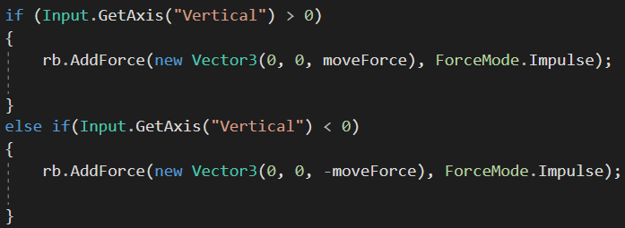

The last part of this script refers to the sound effects of the movement. The lines showed in the next picture show that there is being received information from both Horizontal and Vertical Axis and indicates all values different than Zero. And the micro If statement inside the main ones simply show the Sound would be executed only if it is not being already played at that moment.

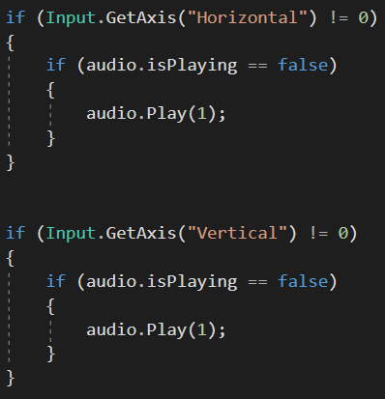

For the purposes of my project Character/Object that I would be moving is restricted from jumping that is why there is no implementation of sound for that, I just added the function to show how it would work. If a jump sound is needed this could be referred in the beginning of the script as a second Audio Source, then just like the movement sound it will receive data but this time from the Action/Space Button and if there is a Value different from zero the sound would be triggered.